**Animals- Image features – file-** 'animal_imagefeaturess.csv'

#importing datat from csv file

setwd("~/train_animal")

A<-read.csv('animal_imagefeaturess.csv', header=TRUE, sep=",")

#checking no. of rows in A

nrow(A)

#checking number of columns in A

ncol(A)

#checking summary of stats of dataframe A

summary(A)

#Sampling the data as train and test

#sampling rows randomly

train.rows<- sample(nrow(A), 160)

#assigning the row values for the sampled row-indexes

#train set

train.set <- A[train.rows,]

#test set

test.set<- A[-train.rows,]

#lets check the number of rows and columns in our train set

nrow(train.set)

nrow(test.set)

#Lets develop the Linear Regression Model now

fit <- lm(formula=Class_label~., data= train.set)

#lets check out the sumamry

summary(fit)

#coefficients and intercepts obtained by the linear model

fit$coefficients

#lets check out the fitted values for our train data

fit$fitted.values

#lets use our model to predict the labels for the test set

predict(fit, test.set)

test.set

#performance on the train set of linear model

#using mean square error

mean_sq_er1= mean(fit$residuals^2)

mean_sq_er1

#performance on the testset of the linear model

y_cap= predict(fit, test.set)

test_residue= test.set$Class_label-y_cap

mean_sq_er_lm_test= mean(test_residue^2)

mean_sq_er_lm_test

Output:

Train errror- 0.092

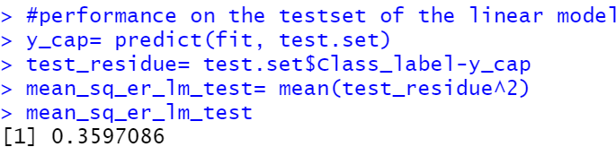

**Animals- Image features – file-** #importing datat from csv file

setwd("~/train_animal")

A<-read.csv('animal_text_featuresand_labelss.csv', header=TRUE, sep=",")

#checking no. of rows in A

nrow(A)

#checking number of columns in A

ncol(A)

#checking summary of stats of dataframe A

summary(A)

#Sampling the data as train and test

#sampling rows randomly

train.rows<- sample(nrow(A), 20)

#assigning the row values for the sampled row-indexes

#train set

train.set <- A[train.rows,]

#test set

test.set<- A[-train.rows,]

#lets check the number of rows and columns in our train set

nrow(train.set)

nrow(test.set)

#Lets develop the Linear Regression Model now

fit <- lm(formula=Class_label~., data= train.set)

#lets check out the sumamry

summary(fit)

#coefficients and intercepts obtained by the linear model

fit$coefficients

#lets check out the fitted values for our train data

fit$fitted.values

#lets use our model to predict the labels for the test set

predict(fit, test.set)

test.set

#performance on the train set of linear model

#using mean square error

mean_sq_er1= mean(fit$residuals^2)

mean_sq_er1

#performance on the testset of the linear model

y_cap= predict(fit, test.set)

test_residue= test.set$Class_label-y_cap

mean_sq_er_lm_test= mean(test_residue^2)

mean_sq_er_lm_test

